See discussions, stats, and author profiles for this publication at: https://www.researchgate.net/publication/381053149

Student Information Management System Project Report II

Article in SSRN Electronic Journal · January 2024
DOI: 10.2139/ssrn.4849994

CITATIONS
3
READS
3,014

1 author:

Krishna prasanna .; Kalyani
Marwadi University
293 PUBLICATIONS 6,187 CITATIONS
SEE PROFILE

All content following this page was uploaded by Kamal Acharya on 05 June 2024.

The user has requested enhancement of the downloaded file.

AN INTERNSHIP REPORT
ON
STUDENT INFORMATION MANAGEMENT SYSTEM
PROJECT BY
KRISHNA PRASANNA AND KALYANI
(MARWADI University)
Date: 2024/01/25

ABSTRACT
Our project explains about the student management. This project mainly explains the various actions related to student details. This project shows some ease in adding, editing and deleting the student details. It also provides a less time consuming process for viewing, adding, editing and deleting the marks of the students.
Our project includes
- Student Registration
- Subject Allocation
- Branch selection
- Semester wise selection.
- Examination marks entry
- Displaying branch and semester wise result.

INTRODUCTION
Student Management System is software which is helpful for students as well as the school authorities. In the current system all the activities are done manually. It is very time consuming and costly. Our Student Management System deals with the various activities related to the students.
There are mainly 3 modules in this software
- User module
- Student Module
- Mark management Module.

In the Software we can register as a user and user has of two types, student and administrator. Administrator has the power to add new user and can edit and delete a user. A student can register as user and can add edit and delete his profile. The administrator can add edit and delete marks for the student. All the users can see the marks.

SYSTEM ANALYSIS

EXISTING SYSTEM:

System Analysis is a detailed study of the various operations performed by a system and their relationships within and outside of the system. Here the key question is- what all problems exist in the present system? What must be done to solve the problem? Analysis begins when a user or manager begins a study of the program using existing system.
During analysis, data collected on the various files, decision points and transactions handled by the present system. The commonly used tools in the system are Data Flow Diagram, interviews, etc. Training, experience and common sense are required for collection of relevant information needed to develop the system. The success of the system depends largely on how clearly the problem is defined, thoroughly investigated and properly carried out through the choice of solution. A good analysis model should provide not only the mechanisms of problem understanding but also the frame work of the solution. Thus it should be studied thoroughly by collecting data about the system. Then the proposed system should be analyzed thoroughly in accordance with the needs.
System analysis can be categorized into four parts.

    - System planning and initial investigation
    - Information Gathering
    - Applying analysis tools for structured analysis
    - Feasibility study
    - Cost/ Benefit analysis.

In the current system we need to keep a number of records related to the student and want to enter the details of the student and the marks manually. In this system only the teacher or the school authority views the mark of the student and they want to enter the details of the student. This is time consuming and has much cost.

PROPOSED SYSTEM

In our proposed system we have the provision for adding the details of the students by themselves. So the overhead of the school authorities and the teachers is become less. Another advantage of the system is that it is very easy to edit the details of the student and delete a student when it found unnecessary. The marks of the student are added in the database and so students can also view the marks whenever they want.
Our proposed system has several advantages
- User friendly interface
- Fast access to database
- Less error
- More Storage Capacity
- Search facility
- Look and Feel Environment
- Quick transaction

All the manual difficulties in managing the student details in a school or college have been rectified by implementing computerization.

FEASIBILITY ANALYSIS

Whatever we think need not be feasible .It is wise to think about the feasibility of any problem we undertake. Feasibility is the study of impact, which happens in the organization by the development of a system. The impact can be either positive or negative. When the positives nominate the negatives, then the system is considered feasible. Here the feasibility study can be performed in two ways such as technical feasibility and Economical Feasibility.

Technical Feasibility:

We can strongly says that it is technically feasible, since there will not be much difficulty in getting required resources for the development and maintaining the system as well. All the resources needed for the development of the software as well as the maintenance of the same is available in the organization here we are utilizing the resources which are available already.

Economical Feasibility

Development of this application is highly economically feasible .The organization needed not spend much money for the development of the system already available. The only thing is to be done is making an environment for the development with an effective supervision. If we are doing so, we can attain the maximum usability of the corresponding resources .Even after the development, the organization will not be in condition to invest more in the organization
.Therefore, the system is economically feasible.

SYSTEM REQUIREMENTS SPECIFICATION

Hardware Requirements

Processor : Pentium III 630MHz RAM : 128 MB
Hard Disk : 20GB

Monitor : 15” Color monitor

Key Board : 104 Keys

Software Requirements

Operating System : Windows NT,

Windows 98, Windows XP.
Language : Java 2 Runtime Environment

Database : MS Access2007.

Functional Requirements

The functional requirements of the system are to the implement the solution for finding the train details and route information in the large existing rail system.

- Input / Output:

The user select the type of train and enter the source and destination codes with which finds the trains details and route information.

- Processing:

The information regarding train details are retrieved from the database.

- Storage Requirements:

The information will be retrieved from the database.

- Control Requirements:

Alerts when any errors are there and when any of the field is not selected.

SYSTEM DESIGN

Introduction

System design is a process through which requirements are translated into a representation of software. Initially the representation depicts a holistic view of software. Subsequent refinement leads to a design representation that is very close to source code. Design is a place where quality fostered in software development. Design provides us with representation of software that can be assessed for quality; this is the only way that can accurately translate the customer requirements into finished software product or system. System design serves as the foundation for all software engineering and software maintenance steps that follow.
We look the design process from three distinct perspectives:

- Conceptual Design
- Logical Design
- Physical Design

The higher view is the conceptual view, followed by the logical view and finally the physical view. In designing an application, we generally begin and end each phase in a sequentially order, although they may overlap one another along the way.

Conceptual Design:

Conceptual Design is the process of acquiring and evaluating, documenting and then validating what the user envisions to be the business relation. It identifies the user and business requirements of the application and leads to a business solution as seen by the user.

All applications are built to solve business problems, and it is important to pay close attention to principle that the business need drives application development. At any point in the design process, the current state of the design should be directly traceable to a business problem and requirements.
To achieve this conceptual design is driven by developing usage scenarios. These scenarios are a direct representation of the user’s view of the solution to a specific business problem. A conceptual view places the emphasize on solving a business problem and deriving a solution that corresponds to the needs and requirements of the users. It is based on deriving the behavior of the solution with a primary emphasizes on the user. Beginning with a emphasis on the activities of the business rather than aspects of software development, underscores the fact that systems exists to serve the business. A strong focus on the user in the beginning of the project will help in maintaining a proper perspective throughput the development lifecycle.The conceptual design results in the first description of what the system does to solve the business problem articulated in the vision/scope document.

Logical Design

Logical Design derives business objects and their related services directly from these usage scenarios. The logical view of the solution provides a basis for evaluating different physical options. It also formalizes the solution for the project team.
The idea of the application is that the system first emerges in logical design.Its boundaries and business objects and it contains the system definition. Logical design specifies the interfaces between the system and external entities,such as users and other systems. Within a system there may be a number of sub-systems, and these boundaries are also specified.
Logical System Design consists of the following steps:

- Input/Output Specifications
- File Specifications
- Processing Specifications
Logical design should be technologically independent as possible, inorder to separate system behavior issues from system implementation issues. Implementation constraints should only be

considered only after the project team verifies that the essential behavior has been incorporated onto a logical design. This approach does not establish a technical direction until the system is well understood and documented.

Physical Design

The purpose of Physical Design is to translate the logical design into a solution that can be implemented effectively, according to performance, administration and development process requirements. This physical view should correctly implement the desired system behavior while meeting the constraints imposed by the technology.
In Physical Design, the perspective shifts from an abstraction of system behavior to an implementation of the behavior. Whereas the logical design is largely technology independent, physical design is necessarily tied to chosen set of technologies, these being the hardware and software on which the application will run.
The aim of physical design is to specify how to build portioned applications from software components. The interaction of these components through defined interfaces results in the desired behavior of the system as a whole. The rules for communicating between components are defined by interaction standards: what a component does and how it communicates are major considerations in physical design.
Physical design consists of the following steps:

- Design the physical media

  - Specify input/output media.
  - Design the database and specify backup procedures.
  - Design physical information flow through the system.
- Plan the system implementation

  - Prepare a conversion schedule target date.
  - Determine training procedure, courses and timetable.

- Device a test and implementation plan.

- Specify any new Hardware/Software usage.

- Update benefits, costs, conversion date and system constraints.

UML Diagrams

Introduction

Design is the first step in the development phase for an engineered product or system. Design is the place where quality is fostered in software development. Design is the only way that we can accurately translate a user’s requirements into a finished software product or system. Software design serves as the foundation for all software engineers and software maintenance steps that follow. Without design we risk building an unstable design -one that will fail when small changes are made, one that may be difficult to test, and one whose quantity cannot be accessed until late in the software engineering process.

Taking software requirements specification document of analysis phase as input to the design phase we have drawn Unified Modeling Language (UML) diagrams. UML depends on the visual modeling of the system. Visual modeling is the process of taking the information from the model and displaying it graphically using some sort of standards set of graphical elements.

UML Diagrams are drawn using the Pace Star UML Diagrammed Software. We seem to able to understand complexity better when it is displayed to us visually as opposed to written textually. By producing visual models of a system, we can show how system works on several levels. We can model and the interactions between the users and the system.

Types of UML Diagrams

Each UML diagram is designed to let developers and customers view a software system from a different perspective and in varying degrees of abstraction. UML diagrams commonly created in visual modeling tools include

Use Case Diagram displays the relationship among actors and use cases.

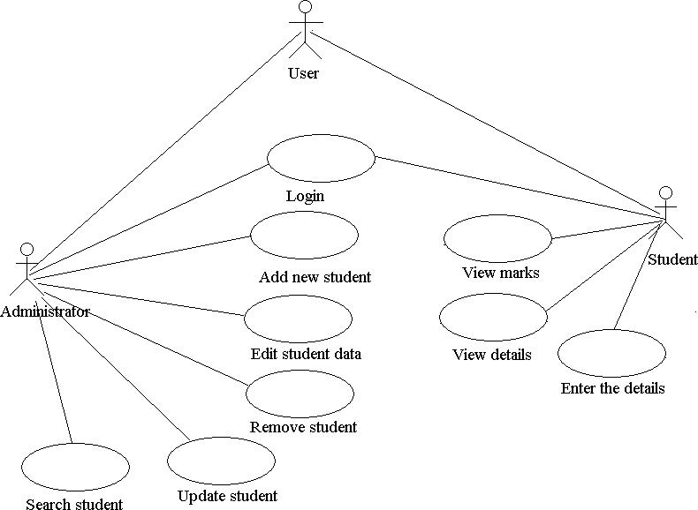

Class Diagram models class structure and contents using design elements such as classes, packages and objects. It also displays relationships such as containment, inheritance, associations and others.

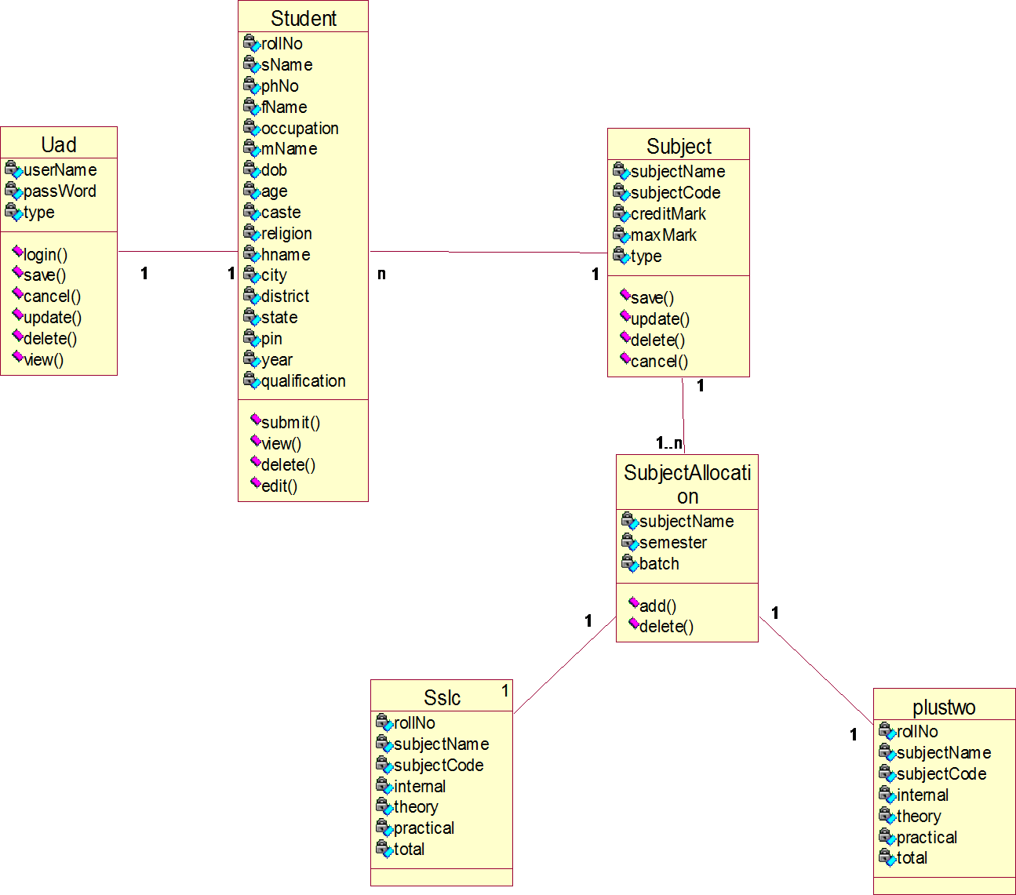

Interaction Diagrams:

Sequence Diagram displays the time sequence of the objects participating in the interaction. This consists of the vertical dimension (time) and horizontal dimension (different objects).

1: login
2: register details
3: edit details
4: delete details
5: register marks
6: allocate subject to semiste wise
7: edit marks
8: delete marks
9: login
10: view details
11: view marks
A:Administra tor
U:User
M:Marks
S : Student

Collaboration Diagram displays an interaction organized around the objects and their links to one another. Numbers are used to show the sequence of messages.

10: view details

A:Administ rator
2: register details
3: edit details
4: delete details
6:
M:Marks
U:User
9: login
11: view marks
1: login
5: register marks
allocate subject to semiste wise 7: edit marks
8: delete marks
S : Student

State Diagram displays the sequence of states that an object of an interaction goes through during its life in response to received stimuli, together with its responses and actions.



user

administr ator
login
login

student

add delete modify

subjet

add delete modify

view

registration faild

marks

Activity Diagram displays a special state diagram where most of the states are action states and most of the transitions are triggered by completion of the actions in the source states. This diagram focuses on flows driven by internal processing.

Physical Diagrams:

Component Diagram displays the high level packaged structure of the code itself. Dependencies among components are shown; include source code components, binary code components, and executable components. Some components exist at compile time, at link time, at run times well as at more than one time.
Deployment Diagram displays the configuration of run-time processing elements and the software components, processes, and objects that live on them. Software component instances represent run-time manifestations of code units.

DATABASE DESIGN

The general theme behind a database is to handle information as an integrated whole. A database is a collection of interrelated data stored with minimum redundancy to serve many users quickly and efficiently. The general objective is to make information access easy quick and flexible for user. In database design several objectives are considered.

Control Redundancy:

Redundant occupies space and therefore, is wasteful. If versions of the data are in different phases of updating the system often gives conflicting information. A unique aspect of database design is storing only once, which controls redundancy and improves system performance.

E-R DIAGRAMS:

Entity-Relationship Model:

The Entity-Relationship data model is based on a perception of a real world, which is consists of set of basic object called entities and relationships among these objects. An entity is an object that exists and is distinguishable from other objects/entity is an object as a concept meaningful to the organization. An entity set is a set of entities of the same type. A primary key is an attribute which when take, allows us to identify uniquely an entity in the entity set.

DATA FLOW DIAGRAM
A data-flow diagram (DFD) is a graphical representation of the "flow" of data through an information system. DFDs can also be used for the visualization of data processing (structured design).

On a DFD, data items flow from an external data source or an internal data store to an internal data store or an external data sink, via an internal process.

A DFD provides no information about the timing or ordering of processes, or about whether processes will operate in sequence or in parallel. It is therefore quite different from a flowchart, which shows the flow of control through an algorithm, allowing a reader to determine what operations will be performed, in what order, and under what circumstances, but not what kinds of data will be input to and output from the system, nor where the data will come from and go to, nor where the data will be stored (all of which are shown on a DFD).

Context Diagram USER
User
System
Report

STUDENT

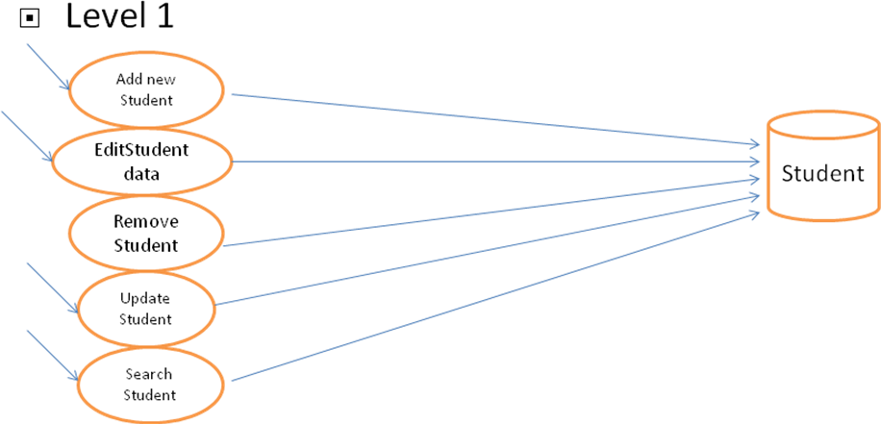

MARKS

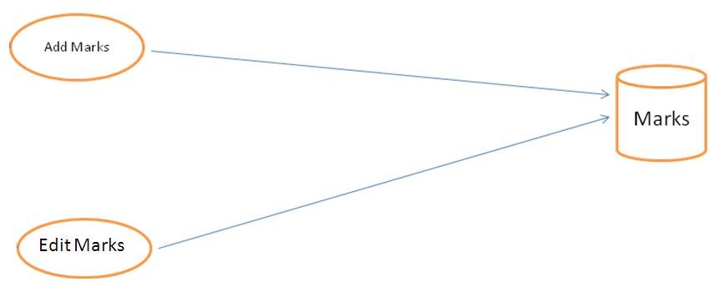

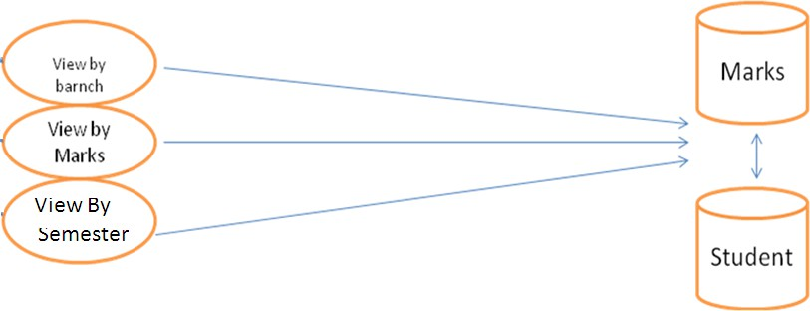

      - TABLES STRUCTURES

Student Table

Field Name | Data Type | Constraint
RollNo | Number | Primary Key
SName | Text(50)
Phno | Text(15)
Sex | Text(10)
FName | Text(50)
Occupation | Text(50)
MName | Text(50)
DOB | Date/Time
Age | Number
Caste | Text(25)
Religion | Text(30)
Hname | Text(50)
City | Text(50)
District | Text(50)
State | Text(50)
Pin | Text(10)
Year | Number
Qualification | Text(25)

UAD Table

Field Name | Data Type | Constraint
Username | Text(25) | Primary Key
Password | Text(15)
Type | Text(15)

Subjects Table

Field Name | Data Type | Constraint
Subjectcode | Text(10) | Primary Key
Subjectname | Text(50)
Creditmark | Number
MaxMark | Number
Type | Text(25)

SubjectAllocation Table

Field Name | Data Type | Constraint
Subjectname | Text(50)
Semester | Number | Primary key
Batch | Text(15)

SSLC1 Table

Field Name | Data Type | Constraint
RollNo | Number | Foreign Key
SubjectName | Text(50)
Subjectcode | Text(15) | Foreign key
Internal | Number
Theory | Number
Practical | Number
Total | Number

SSLC2 Table

Field Name | Data Type | Constraint
RollNo | Number | Foreign Key
SubjectName | Text(50)
Subjectcode | Text(15) | Foreign Key
Internal | Number
Theory | Number
Practical | Number
Total | Number

SSLC3 Table

Field Name | Data Type | Constraint
RollNo | Number | Foreign Key
SubjectName | Text(50)
Subjectcode | Text(15) | Foreign Key
Internal | Number
Theory | Number
Practical | Number
Total | Number

SSLC4 Table

Field Name | Data Type | Constraint
RollNo | Number | Foreign Key
SubjectName | Text(50)
Subjectcode | Text(15) | Foreign Key
Internal | Number
Theory | Number
Practical | Number
Total | Number

SSLC5 Table

Field Name | Data Type | Constraint
RollNo | Number | Foreign Key
SubjectName | Text(50)
Subjectcode | Text(15) | Foreign Key
Internal | Number
Theory | Number
Practical | Number
Total | Number

SSLC6 Table

Field Name | Data Type | Constraint
RollNo | Number | Foreign Key
SubjectName | Text(50)
Subjectcode | Text(15) | Foreign Key
Internal | Number
Theory | Number
Practical | Number
Total | Number

PLUSTWO1 Table

Field Name | Data Type | Constraint
RollNo | Number | Foreign key
SubjectName | Text(50)
Subjectcode | Text(15) | Foreign Key
Internal | Number
Theory | Number
Practical | Number
Total | Number

PLUSTWO2 Table

Field Name | Data Type | Constraint
RollNo | Number | Foreign key
SubjectName | Text(50)
Subjectcode | Text(15) | Foreign Key
Internal | Number
Theory | Number
Practical | Number
Total | Number

PLUSTWO3 Table

Field Name | Data Type | Constraint
RollNo | Number | Foreign key
SubjectName | Text(50)
Subjectcode | Text(15) | Foreign Key
Internal | Number
Theory | Number
Practical | Number
Total | Number

PLUSTWO4 Table

Field Name | Data Type | Constraint
RollNo | Number | Foreign key
SubjectName | Text(50)
Subjectcode | Text(15) | Foreign Key
Internal | Number
Theory | Number
Practical | Number
Total | Number

PLUSTWO5 Table

Field Name | Data Type | Constraint
RollNo | Number | Foreign key
SubjectName | Text(50)
Subjectcode | Text(15) | Foreign Key
Internal | Number
Theory | Number
Practical | Number
Total | Number

SYSTEM IMPLEMENTATION

Introduction

Implementation is the stage in the project where the theoretical design is turned into a working system. The implementation phase constructs, installs and operates the new system. The most crucial stage in achieving a new successful system is that it will work efficiently and effectively.
There are several activities involved while implementing a new project. They are

- End user training
- End user Education
- Training on the application software
- System Design
- Parallel Run and To New System
- Post implementation Review

End user Training:

The successful implementation of the new system will purely upon the involvement of the officers working in that department. The officers will be imparted the necessary training on the new technology

End User Education:

The education of the end user start after the implementation and testing is over. When the system is found to be more difficult to understand and complex, more effort is put to educate the end used to make them aware of the system, giving them lectures about the new system and providing them necessary documents and materials about how the system can do this.

Training of application software:

After providing the necessary basic training on the computer awareness, the users will have to be trained upon the new system such as the screen flows and screen design type of help on the screen, type of errors while entering the data, the corresponding validation check at each entry and the way to correct the data entered. It should then cover information needed by the specific user or group to use the system.

Post Implementation View:

The department is planning a method to know the states of t he past implementation process. For that regular meeting will be arranged by the concerned officers about the implementation problem and success.

Project Modules

Our application deals with three modules

- User module
- Student Module
- Mark management Module.

User Module:

- In the Software we can register as a user and user has of two types, student and administrator.
- Administrator has the power to add new user and can edit and delete a user. A student can register as user and can add edit and delete his profile.
- The administrator can add, edit and delete marks for the student. All the users can see the marks.

Student Module:

- In this student module Administrator will register the details of the student.
- Administrator can view the details of the student by giving admission number.
- Administrator can also edit the details of the student by giving admission number
- Administrator can also delete the details of the student by giving admission number

Marks Management Module

- In this module Administrator register all subjects and also provide subject code to each and every subject.
- Assign subjects to every branch in semester wise.

- Using subject code Administrator edit and delete the subjects.

- Administrator enters marks of the Student in semester wise.

- Administrator can also edit and delete the marks of the student.

5.2 SCREENS

Login
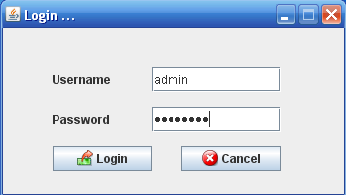

Description:

Here we will give username and password to Login in to the Student Screen or Adminstrator Screen.

Add New User
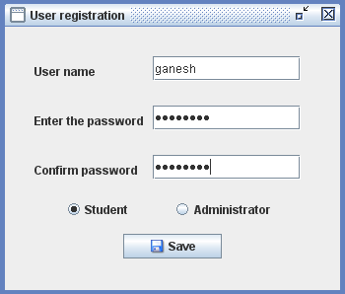

Description:

Here we can register new user by giving username and password and conforming the password given .And by selecting whether he is the student or Administrator.

Edit User Type
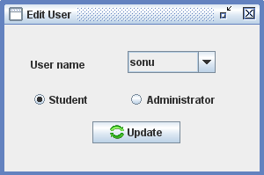

Description:

Here we can edit the register user type into another user .

Delete User
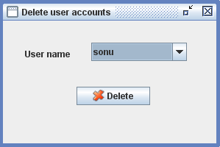

Description:

Here we can delete the register user by clicking Delete button.

View User details

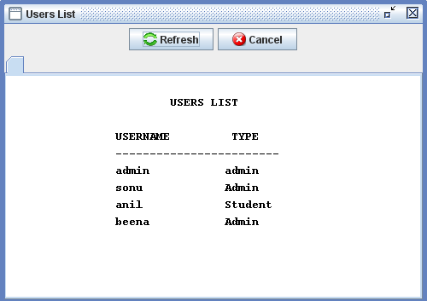

Description:

We can view the entire list of users we have registered.

Student Registration
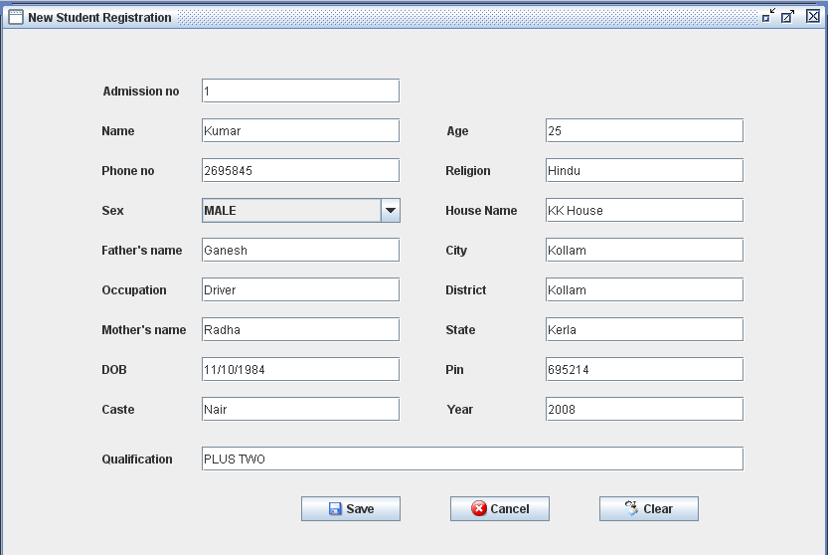

Description:

Here we can register all the details of the student and by clcking save button , the details will store in the database.

Edit Student Details
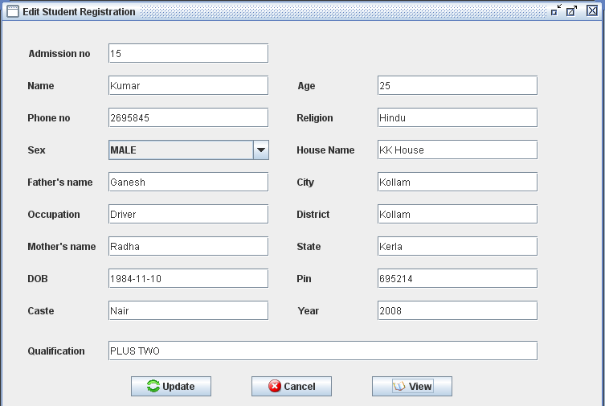

Description:

Here we can edit the details of student by giving Admission no as input and when clicking view button we can view entire detail of student and we can change any detail of the student and after clicking update button the changes will store in database.

Delete Student details
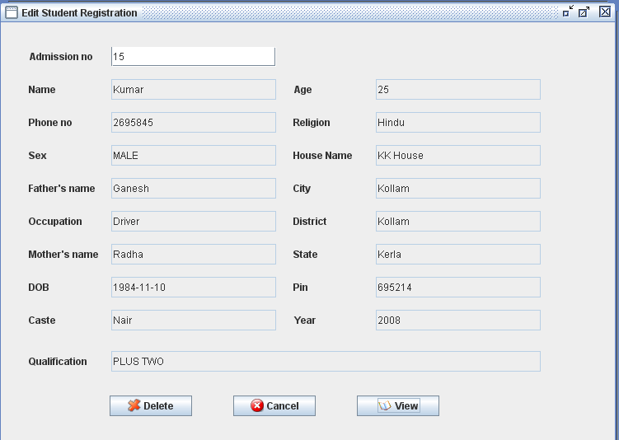

Description:

Here if we want to delete the any student we can delete by clicking Delete button.

View Student Details
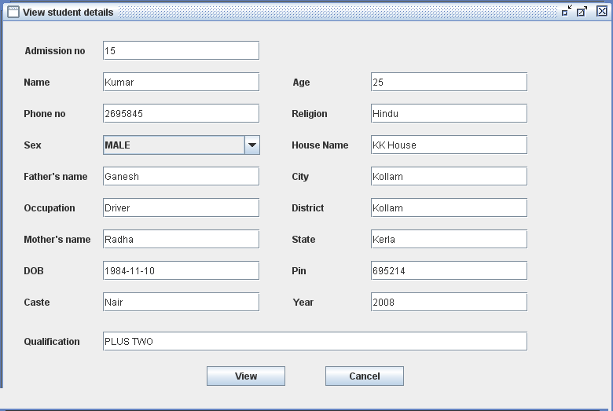

Description:

We can view the entire details of the particular student by giving their Admission number as input.

Add New Subjects
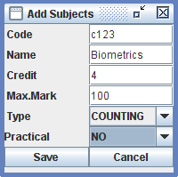

Description:

Here we can add new subjects by giving entire details of the subject and after clicking save button ,details will store in the database.

Edit Subject details
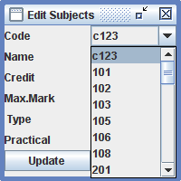
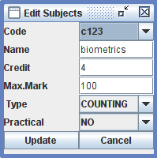

Description:

Here we can edit the subject details by givng subject code as input.By clicking update button the details will be store in the database .

Delete Subject details
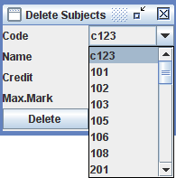
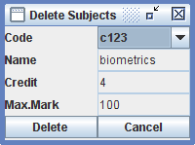

Description:

Here we can delete the given subject by giving subject code as input. By clicking delete button the details will be deleted in the database.

Subject Allocation
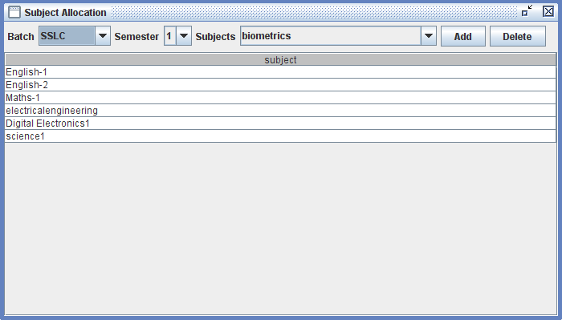

Description:

Here we can allocate the subjects to all the batches by semester wise.

Add/Edit Mark Details
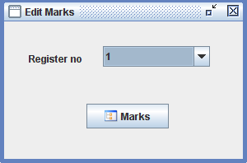
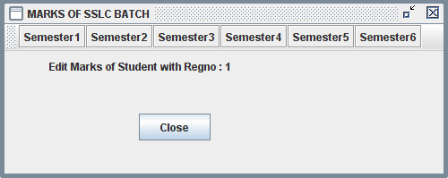
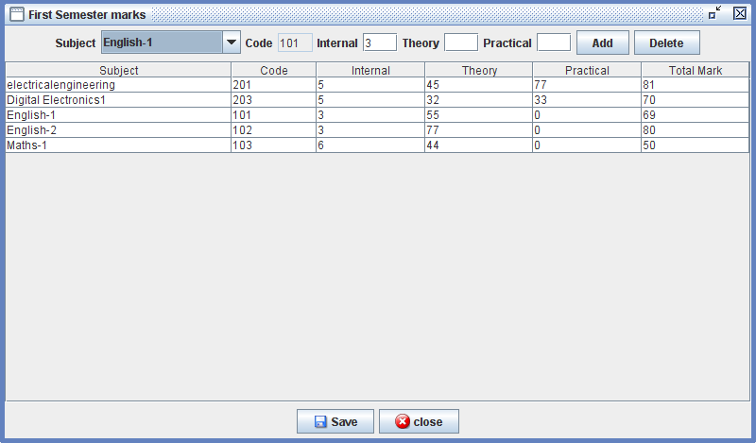

Description:

Here we can add and edit the marks of the particular student of the particular subject by semester wise.

View Marks
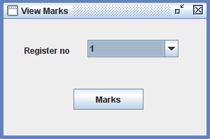

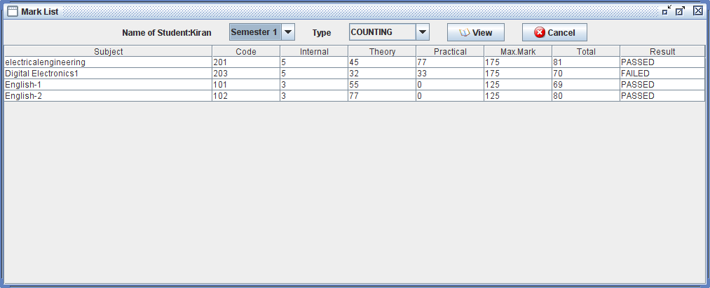

Description:

We can view the marks of the particular student by semester wise by giving Register number as input.We can view by clicking view button.

SYSTEM TESTING

Introduction

Is the menu bar displayed in the appropriate contested some system related features included either in menus or tools? Do pull –Down menu operation and Tool-bars work properly? Are all menu function and pull down sub function properly listed ?; Is it possible to invoke each menu function using a logical assumptions that if all parts of the system are correct, the goal will be successfully achieved .? In adequate testing or non-testing will leads to errors that may appear few months later.
This create two problem

- Time delay between the cause and appearance of the problem.

- The effect of the system errors on files and records within the system

The purpose of the system testing is to consider all the likely variations to which it will be suggested and push the systems to limits.
The testing process focuses on the logical intervals of the software ensuring that all statements have been tested and on functional interval is conducting tests to uncover errors and ensure that defined input will produce actual results that agree with the required results. Program level testing, modules level testing integrated and carried out.

Testing Methods

There are two major type of testing they are

    - White Box Testing.
    - Black Box Testing.

White Box Testing

White box sometimes called “Glass box testing” is a test case design uses the control structure of the procedural design to drive test case.
Using white box testing methods, the following tests were made on the system

- All independent paths within a module have been exercised once. In our system, ensuring that case was selected and executed checked all case structures. The bugs that were prevailing in some part of the code where fixed
- All logical decisions were checked for the truth and falsity of the values.

Black box Testing

Black box testing focuses on the functional requirements of the software. This is black box testing enables the software engineering to derive a set of input conditions that will fully exercise all functional requirements for a program. Black box testing is not an alternative to white box testing rather it is complementary approach that is likely to uncover a different class of errors that white box methods like..
- Interface errors

- Performance in data structure

- Performance errors

- Initializing and termination errors

Unit testing

Unit testing is a software verification and validation method in which a programmer tests if individual units of source code are fit for use.
A unit is the smallest testable part of an application. In procedural programming a unit may be an individual function or procedure.
Ideally, each test case is independent from the others: substitutes like method stubs, objects, fakes and test harnesses can be used to assist testing a module in isolation.

Integration Testing:

This testing is sometimes called Integration and Testing. Integration testing is the phase in software testing in which individual software modules are combined and tested as a group. It occurs after unit testing and before system testing. Integration testing takes as its input modules that have been unit tested, groups them in larger aggregates, applies tests defined in an integration test plan to those aggregates and delivers as its output the integrated system ready for system testing.

Validation Testing:

Validation Testing can be defined in many ways, but a simple definition is that validation succeeds when the software functions in a manner that can reasonably expected by a customer. After validation test has been conducted, one of the following two possible conditions exists. The functions or performance characteristics confirm to specification and are accepted.

- In the administrator and marks modules, all the fields must be filled.
- In the student registration, mobile number should contain exactly 10 numbers.

User Acceptance Testing:

User acceptance of a system is a key factor of any system. The system under consideration is tested for the acceptance by constantly keeping in touch with the prospective system users at the same time of developing and marketing changes whenever required. This is done in regard to the following points:

- Input Screen Design
- Output Screen Design

  - Test Cases

NO | INPUT GIVEN | EXPECTED OUTPUT | ACTUAL OUTPUT OCCURED | TEST PASS | ACTION TAKEN
1 | Admin , pass | Admin Home page | Admin Home page | Yes | -
2 | bindu , bindu | student Home page | student Home page | Yes | -
3 | Admin, kumar | Admin Home page | Invalid password for user Admin | No | The wrong password kumar is given for user Admin.
4 | phoneNumber | Student registration successful. | Please enter a valid phone number. | No | The phone number given is of 9 numbers.
5 | Adding of  subject into the specified branch according to semester wise | Subject Allocated Sucessfully | Alredy Subject is allocated | No | The subject name given was already exists.

CONCLUSION

Our project is only a humble venture to satisfy the needs in an Institution. Several user friendly coding have also adopted. This package shall prove to be a powerful package in satisfying all the requirements of the organization.

The objective of software planning is to provide a frame work that enables the manger to make reasonable estimates made within a limited time frame at the beginning of the software project and should be updated regularly as the project progresses.

BIBLIOGRAPHY

- http://www.javaworld.com/javaworld/jw-01-1998/jw-01-bookreview.html
- Database Programming with JDBC and Java by O'Reilly
- Head First Java 2nd Edition
- http://www.jdbc-tutorial.com/
- Java and Software Design Concepts by APress

Reference

Acharya, Kamal. "STUDENT INFORMATION MANAGEMENT
SYSTEM." Authorea Preprints (2023).
Acharya, Kamal. "Library Management System." Available at SSRN4807104 (2019). ACHARYA, KAMAL, et al. "LIBRARY MANAGEMENT SYSTEM." (2019).
Acharya, Kamal. "Online bus reservation system project report." Authorea Preprints (2024).
Acharya, Kamal. "Online bus reservation system project report." (2024). Acharya, Kamal. “Online Bus Reservation System.” SSRN ElectroNIC ASIA Journal (2024): n. pag.
Acharya, Kamal. “Student Information Management System Project.” SSRN ElectroNIC ASIA Journal (2024): n. pag.
Acharya, Kamal. “ATTENDANCE MANAGEMENT SYSTEM.” International Research Journal of Modernization in Engineering Technology and
Science (2023): n. pag.

Acharya, Kamal. “College Information Management System.” SSRN ElectroNIC ASIA Journal (2024): n. pag.
Acharya, Kamal, Attendance Management System Project (April 28, 2024). Available at
SSRN: https://ssrn.com/abstract=4810251 or http://dx.doi.org/10.2139/ssrn.4810251

Acharya, Kamal, Online Food Order System (May 2, 2024). Available at
SSRN: https://ssrn.com/abstract=4814732 or http://dx.doi.org/10.2139/ssrn.4814732 Acharya, Kamal, University management system project. (May 1, 2024). Availableat SSRN: https://ssrn.com/abstract=4814103 or http://dx.doi.org/10.2139/ssrn.4814103 Acharya, Kamal, Online banking management system. (May 1, 2024). Available at SSRN: https://ssrn.com/abstract=4813597 or http://dx.doi.org/10.2139/ssrn.4813597
Acharya, Kamal, Online Job Portal Management System (May 5, 2024). Available at SSRN: https://ssrn.com/abstract=4817534 or http://dx.doi.org/10.2139/ssrn.4817534
Acharya, Kamal, Employee leave management system. (May 7, 2024). Available
at SSRN: https://ssrn.com/abstract=4819626 or http://dx.doi.org/10.2139/ssrn.4819626 Acharya, Kamal, Online electricity billing project report. (May 7, 2024). Available at SSRN: https://ssrn.com/abstract=4819630 or http://dx.doi.org/10.2139/ssrn.4819630
Acharya, Kamal, POLICY MANAGEMENT SYSTEM PROJECT REPORT. (December 10, 2023).
Available at
SSRN: https://ssrn.com/abstract=4831694 or http://dx.doi.org/10.2139/ssrn.4831694 Acharya, Kamal, Online job placement system project report. (January 10, 2023). Available at SSRN: https://ssrn.com/abstract=4831638 or http://dx.doi.org/10.2139/ssrn.4831638
Acharya, Kamal, Software testing for project report. (May 16, 2023). Available at SSRN: https://ssrn.com/abstract=4831028 or http://dx.doi.org/10.2139/ssrn.4831028
Acharya, Kamal, ONLINE CRIME REPORTING SYSTEM PROJECT. (August 10, 2022).
Available at
SSRN: https://ssrn.com/abstract=4831015 or http://dx.doi.org/10.2139/ssrn.4831015
Acharya, Kamal, Burber ordering system project report. (October 10, 2022). Available at SSRN: https://ssrn.com/abstract=4832704 or http://dx.doi.org/10.2139/ssrn.4832704
Acharya, Kamal, Teachers Record Management System Project Report (December 10, 2023). Available at
SSRN: https://ssrn.com/abstract=4833821 or http://dx.doi.org/10.2139/ssrn.4833821
Acharya, Kamal, Dairy Management System Project Report (December 20, 2020). Available at SSRN: https://ssrn.com/abstract=4835231 or http://dx.doi.org/10.2139/ssrn.4835231
Acharya, Kamal, Electrical Shop Management System Project (December 10, 2019). Available at SSRN: https://ssrn.com/abstract=4835238 or http://dx.doi.org/10.2139/ssrn.4835238

Acharya, Kamal, Online book store management system project report. (Febuary 10, 2020). Available at
SSRN: https://ssrn.com/abstract=4835277 or http://dx.doi.org/10.2139/ssrn.4835277
Acharya, Kamal, Paint shop management system project report. (January 10, 2019). Available at SSRN: https://ssrn.com/abstract=4835441 or http://dx.doi.org/10.2139/ssrn.4835441
Acharya, Kamal, Supermarket billing system project report. (August 10, 2021). Available at SSRN: https://ssrn.com/abstract=4835474 or http://dx.doi.org/10.2139/ssrn.4835474
Acharya, Kamal, Online texi booking system project report. (March 10, 2022). Available at SSRN: https://ssrn.com/abstract=4837729 or http://dx.doi.org/10.2139/ssrn.4837729
Acharya, Kamal, Online car servicing system project report. (March 10, 2023). Available at SSRN: https://ssrn.com/abstract=4837832 or http://dx.doi.org/10.2139/ssrn.4837832
Acharya, Kamal, School management system project report. (July 10, 2021). Available at SSRN: https://ssrn.com/abstract=4837837 or http://dx.doi.org/10.2139/ssrn.4837837
Acharya, Kamal, Furniture Showroom Management System Project Report (March 21, 2021). Available at
SSRN: https://ssrn.com/abstract=4839422 or http://dx.doi.org/10.2139/ssrn.4839422
Acharya, Kamal, Online Vehicle Rental System Project Report (March 21, 2019). Available at SSRN: https://ssrn.com/abstract=4839429 or http://dx.doi.org/10.2139/ssrn.4839429
Acharya, Kamal, Fruit Shop Management System Project Report (August 10, 2023). Available at SSRN: https://ssrn.com/abstract=4841048 or http://dx.doi.org/10.2139/ssrn.4841048
Acharya, Kamal, Hall Booking Management System Project Report (December 21, 2023). Available at
SSRN: https://ssrn.com/abstract=4841055 or http://dx.doi.org/10.2139/ssrn.4841055
Acharya, Kamal, Lundry Management System Project Report (October 21, 2023). Available at SSRN: https://ssrn.com/abstract=4841059 or http://dx.doi.org/10.2139/ssrn.4841059
Acharya, Kamal, A CASE STUDY OF CINEMA MANAGEMENT SYSTEM PROJECT (September
25, 2023). Available at SSRN: https://ssrn.com/abstract=4841209 or http://dx.doi.org/10.2139/ssrn.4841209
Acharya, Kamal, A CASE STUDY ON ONLINE TICKET BOOKING SYSTEM PROJECT (May 25,
2024). Available at SSRN: https://ssrn.com/abstract=4841210 or http://dx.doi.org/10.2139/ssrn.4841210

Acharya, Kamal, ONLINE DATING MANAGEMENT SYSTEM PROJECT REPORT. (April 25,
2023). Available at SSRN: https://ssrn.com/abstract=4842066 or http://dx.doi.org/10.2139/ssrn.4842066
Acharya, Kamal, ONLINE RESUME BUILDER MANAGEMENT SYSTEM PROJECT REPORT.
(April 25, 2021). Available at SSRN: https://ssrn.com/abstract=4842071 or http://dx.doi.org/10.2139/ssrn.4842071
Acharya, Kamal, TOLL TEX MANAGEMENT SYSTEM PROJECT REPORT (August 21, 2023).
Available at
SSRN: https://ssrn.com/abstract=4842082 or http://dx.doi.org/10.2139/ssrn.4842082
Acharya, Kamal, Chat Application Through Client Server Management System Project Report (June 25, 2023). Available at SSRN: https://ssrn.com/abstract=4842761 or http://dx.doi.org/10.2139/ssrn.4842761
Acharya, Kamal, Web Chatting Application Management System Project Report (April 25, 2022). Available at
SSRN: https://ssrn.com/abstract=4842771 or http://dx.doi.org/10.2139/ssrn.4842771
Acharya, Kamal, Automobile management system project report (May 25, 2022). Available at SSRN: https://ssrn.com/abstract=4846917 or http://dx.doi.org/10.2139/ssrn.4846917
Acharya, Kamal, College bus management system project report (April 25, 2023). Available at SSRN: https://ssrn.com/abstract=4846920 or http://dx.doi.org/10.2139/ssrn.4846920
Acharya, Kamal, Courier management system project report (May 25, 2023). Available at SSRN: https://ssrn.com/abstract=4846922 or http://dx.doi.org/10.2139/ssrn.4846922
Acharya, Kamal, Event management system project report (April 25, 2021). Available at SSRN: https://ssrn.com/abstract=4846927 or http://dx.doi.org/10.2139/ssrn.4846927
Acharya, Kamal, Library management system project report II (May 25, 2020). Available at SSRN: https://ssrn.com/abstract=4848857 or http://dx.doi.org/10.2139/ssrn.4848857

APPENDIX

Introduction To Languages
JAVA
The Java programming language is robust and versatile, enabling developers to:
- Write software on one platform and run in on another
- Create programs to run with a web browser
- Develop server-side applications

An overview of the Java’s architecture

Java VM for
Macintosh
Java VM for
windows
w
Java VM for
Unix
Java Applications

Macintosh
running Macos
Desktop PC
running Windows
Workstation running Unix

The java platform differs from most other platforms in that it’s a software-only platform that runs on top of other hardware-based platforms.
The java platform has two components:
- The java virtual machine (JVM)
- The java application programming interface (Java API)

Java technology is a portfolio of products that are based on the power of network sand the idea that the same software should run on many different kinds of systems and devices.

J2EE:

Java platform, Enterprise Edition or Java EE is a widely used platform for server programming in the Java Programming language. The Java EE platform differs from the Java Standard Edition Platform(Java SE) in that it adds libraries which functionality to deploy fault-tolerant, distributed, multi-tier Java software, based largely on modular components running on an application server. The J2EE1.4 SDK beta was released by Sun in December 2002.

Introduction to SQL :

Database

A database management, or DBMS, gives the user access to their data and helps them transform the data into information. Such database management systems include dBase, paradox, IMS, SQL Server and SQL Server. These systems allow users to create, update and extract information from their database.

A database is a structured collection of data. Data refers to the characteristics of people, things and events. SQL Server stores each data item in its own fields. In SQL Server, the fields relating to a particular person, thing or event are bundled together to form a single complete unit of data, called a record (it can also be referred to as raw or an occurrence). Each record is made up of a number of fields. No two fields in a record can have the same field name.

SQL Server Tables

SQL Server stores records relating to each other in a table. Different tables are created for the various groups of information. Related tables are grouped together to form a database.

Primary Key

Every table in SQL Server has a field or a combination of fields that uniquely identifies each record in the table. The Unique identifier is called the Primary Key, or simply the Key. The primary key provides the means to distinguish one record from all other in a table. It allows the user and the database system to identify, locate and refer to one particular record in the database.

Relational Database

Sometimes all the information of interest to a business operation can be stored in one table. SQL Server makes it very easy to link the data in multiple tables. Matching an employee to the department in which they work is one example. This is what makes SQL Server a relational database management system, or RDBMS. It stores data in two or more tables and enables you to define relationships between the table and enables you to define relationships between the tables.

Foreign Key

When a field is one table matches the primary key of another field is referred to as a foreign key. A foreign key is a field or a group of fields in one table whose values match those of the primary key of another table.

Referential Integrity

Not only does SQL Server allow you to link multiple tables, it also maintains consistency between them. Ensuring that the data among related tables is correctly matched is referred to as maintaining referential integrity.

Advantages of RDBMS

- Redundancy can be avoided
- Inconsistency can be eliminated
- Data can be Shared
- Standards can be enforced
- Security restrictions ca be applied
- Integrity can be maintained
- Conflicting requirements can be balanced
- Data independence can be achieved.

Disadvantages of DBMS

A significant disadvantage of the DBMS system is cost. In addition to the cost of purchasing of developing the software, the hardware has to be upgraded to allow for the extensive programs and the workspace required for their execution and storage. While centralization reduces duplication, the lack of duplication requires that the database be adequately backed up so that in case of failure the data can be recovered.

Features of SQL Server(RDBMS)

SQL SERVER is one of the leading database management systems (DBMS) because it is the only Database that meets the uncompromising requirements of today’s most demanding information systems. From complex decision support systems (DSS) to the most rigorous online transaction processing (OLTP) application, even application that require simultaneous DSS and OLTP access to the same critical data, SQL Server leads the industry in both performance and capability
SQL SERVER is a truly portable, distributed, and open DBMS that delivers unmatched performance, continuous operation and support for every database.
SQL SERVER RDBMS is high performance fault tolerant DBMS which is specially designed for online transactions processing and for handling large database application.
SQL SERVER with transactions processing option offers two features which contribute to very high level of transaction processing throughput, which are:The row level lock manager

Enterprise wide Data Sharing

The unrivaled portability and connectivity of the SQL SERVER DBMS enables all the systems in the organization to be linked into a singular, integrated computing resource.

Portability

SQL SERVER is fully portable to more than 80 distinct hardware and operating systems platforms, including UNIX, MSDOS, OS/2, Macintosh and dozens of proprietary platforms. This portability gives complete freedom to choose the database sever platform that meets the system requirements.

Open Systems

SQL SERVER offers a leading implementation of industry –standard SQL. SQL Server’s open architecture integrates SQL SERVER and non –SQL SERVER DBMS with industries most comprehensive collection of tools, application, and third party software products SQL Server’s Open architecture provides transparent access to data from other relational database and even non- relational database.

Distributed Data Sharing

SQL Server’s networking and distributed database capabilities to access data stored on remote server with the same ease as if the information was stored on a single local computer. A single SQL statement can access data at multiple sites. You can store data where system requirements such as performance, security or availability dictate.

Unmatched Performance

The most advanced architecture in the industry allows the SQL SERVER DBMS to deliver unmatched performance.

Sophisticated Concurrency Control

Real World applications demand access to critical data. With most database Systems application becomes “contention bound” – which performance is limited not by the CPU power or by disk I/O, but user waiting on one another for data access . SQL Server employs full, unrestricted row-level locking and contention free queries to minimize and in many cases entirely eliminates contention wait times.

Introduction To JDBC

JDBC technology is an API(included in both J2SE and J2EE releases) that provides cross DBMS connectivity to a wide range of SQL database and access to other tabular data sources, such as spreadsheets or flat files. With a JDBC technology-enabled driver, you can connect all corporate data even in a heterogeneous environment.
The JDBC API makes it possible to do three things:

    - Establish a connection with a database or access any tabular data source
    - Send SQL statements
    - Process the results

Types of JDBC technology drives

JDBC technology drivers fit into one of four categories:

    - A JDBC-ODBC bridge provides JDBC API access via one or more ODBC drivers.
    - A native-API partly Java technology-enabled driver converts JDBC calls into calls on the client API for Oracle, Sybase, Informix, DB2, or other DBMS.
    - A net-protocol fully Java technology-enabled driver translates JDBC API calls into a DBMS-independent net protocol which is then translated to a DBMS protocol by a server.
    - A native-protocol fully Java technology-enabled driver converts JDBC technology calls into the network protocol used by DBMSs directly.

JDBC Architecture:

The JDBC Architecture consists of two layers:

The JDBC API, which provides the application-to-JDBC Manager connection.

The JDBC Driver API, which supports the JDBC Manager-to-Driver Connection. The JDBC API uses a driver manager and database-specific drivers to provide transparent connectivity to heterogeneous databases. The JDBC driver manager ensures that the correct driver is used to access each data source. The location of the driver manager with respect to the JDBC drivers and the Java application is shown in the figure below:

Java Application
JDBC API
JDBC Driver
Manager
JDBC Driver
JDBC Driver
JDBC Driver
Oracle
SQL
Server
ODBC
Data
Source

Sample Code

Code for Login Page

public class Login extends JFrame implements ActionListener {

Container c = getContentPane(); private JButton btnLogin, btnCancel; private JLabel lblUName, lblPasswd; private JTextField txtUName;
private JPasswordField txtPasswd;

public Login() { super("Login ..."); this.setSize(350, 200); this.setLayout(null);
this.setResizable(false); this.setLocation((Settings.getScreenSize().width / 2)
- 175, (Settings.getScreenSize().height / 2) - 150); this.setDefaultCloseOperation(EXIT_ON_CLOSE);

lblUName = new JLabel("Username"); lblPasswd = new JLabel("Password"); txtUName = new JTextField(); txtPasswd = new JPasswordField(); btnLogin = new JButton("Login", new
ImageIcon(ClassLoader.getSystemResource("Images/login.png"))); btnCancel = new JButton("Cancel",new
ImageIcon(ClassLoader.getSystemResource("Images/cancel.png")))
;
lblUName.setBounds(50, 40, 140, 25);
txtUName.setBounds(150, 40, 130, 25);
lblPasswd.setBounds(50, 80, 140, 25);

txtPasswd.setBounds(150, 80, 130, 25);
btnLogin.setBounds(50, 120, 100, 25);
btnCancel.setBounds(180, 120, 100, 25); btnLogin.addActionListener(this); btnCancel.addActionListener(this); this.add(lblUName); this.add(lblPasswd); this.add(txtUName); this.add(txtPasswd); this.add(btnLogin); this.add(btnCancel);
}//constructor closed
public void actionPerformed(ActionEvent e) { if (e.getSource() == btnLogin) {
try { Class.forName("sun.jdbc.odbc.JdbcOdbcDriver"); Connection con =
DriverManager.getConnection("jdbc:odbc:student");
try {
Statement st = con.createStatement(); ResultSet rs = st.executeQuery("SELECT *
FROM UAD WHERE Username='" + txtUName.getText() +
"' and Password='" +
txtPasswd.getText() + "'");
if (rs.next()) {
if (rs.getString(3).equals("Student"))
{
userMDI frm = new userMDI(); frm.setVisible(true);
} else {
new
frmAdminMDI().setVisible(true);

}
this.dispose();
}else{

JOptionPane.showMessageDialog(null,"Invalid username or password","Invalid",JOptionPane.ERROR_MESSAGE);
}
con.close();

} catch (Exception ex) { JOptionPane.showMessageDialog(null,
"Invalid username or password", "Invalid", JOptionPane.ERROR_MESSAGE);
txtUName.setText(""); txtPasswd.setText("");
}
} catch (Exception x) {
JOptionPane.showMessageDialog(null, "Unable to connect to the database", "Connection error", JOptionPane.ERROR_MESSAGE);
}
}

if (e.getSource() == btnCancel) { System.exit(0);
}
}actionPerformed() closed
public static void main(String args[]) { new Login().setVisible(true);
}
}

